Bahria University,

Karachi Campus



LAB EXPERIMENT NO.

**05**

LIST OF TASKS

|  |  |
| --- | --- |
| TASK NO | OBJECTIVE |
| 1 | 1. Write query that retrieve those cities of Customers where any supplier belongs to. 2. Write query that retrieve those cities of Customers where no single supplier belongs to. 3. Write query that retrieve the regions of Employees and Suppliers. 4. List distinct cities from of customers and suppliers, country must be Germany. 5. Lists all customers and suppliers (ContactName, City, and Country). |

Submitted On:

**Date: 11-3-2024__**

**Exercise**

1. **Write query that retrieve those cities of Customers where any supplier belongs to.**

**Solution:**

use Northwind

SELECT DISTINCT c.City

FROM Customers c

WHERE EXISTS (

SELECT 1

FROM Suppliers s

WHERE s.City = c.City

);

**Output:**

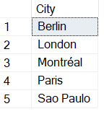

1. **Write query that retrieve those cities of Customers where no single supplier belongs to.**

**Solution:**

use Northwind

SELECT DISTINCT c.City FROM Customers c WHERE NOT EXISTS SELECT 1 FROM Suppliers s

WHERE s.City = c.City );

**Output:**

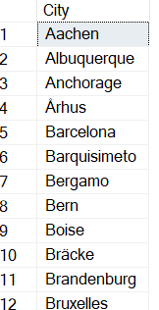

1. **Write query that retrieve the regions of Employees and Suppliers.**

**Solution:**

use Northwind

SELECT DISTINCT E.Region AS Employee_Region, S.Region AS Supplier_Region

FROM Employees E

JOIN Suppliers S ON E.Region = S.Region;

**Output:**



1. **List distinct cities from of customers and suppliers, country must be Germany.**

**Solution:**

use Northwind

SELECT DISTINCT City

FROM (

SELECT City, Country

FROM Customers

UNION

SELECT City, Country

FROM Suppliers

) AS Combined

WHERE Country = 'Germany';

**Output:**

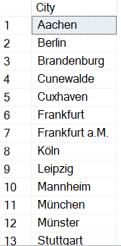

1. **Lists all customers and suppliers (ContactName, City, and Country).**

**Solution:**

use Northwind

SELECT ContactName, City, Country

FROM (

SELECT ContactName, City, Country

FROM Customers

UNION ALL

SELECT ContactName, City, Country

FROM Suppliers

) AS Combined;

**Output:**

